IEEE Spectrum Native Insights Advertising Behavior, Production Specs & Best Practices
Each campaign will include 8 sponsor-supplied content assets per month. Each asset will:
- Be Included on IEEE Spectrum home page;
- Be housed under Professional Resources;
- Have its own individual post page from which the user can link to sponsor-supplied content;
- Appear under ‘ related stories’ tagged to spectrum.ieee.org content;
- Appear on the Sponsor’s asset landing page where all the Sponsor’s campaign content will be posted
1. & 2. The IEEE Spectrum Home page
2 sponsor-supplied assets per week (one every other business day) will be posted to the home page, and then rotated twice per week appearing run of site (ROS.) Each asset will be marked as “Sponsored,” and also be tagged to run with an allocated IEEE Spectrum content navigation throughout the site.
The drop down under “Professional Resources” on the page (2) will navigate to the Sponsor’s landing page (5).
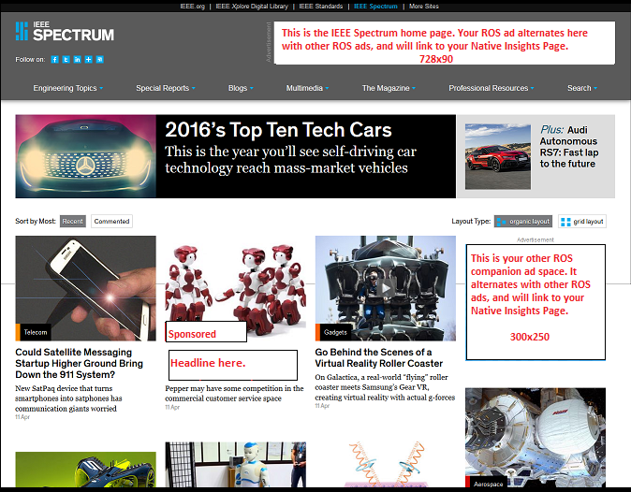

3. The Sponsor’s Individual Content Asset Page
Each sponsored content asset will have a dedicated individual page. The content should not be gated and will appear in the style of and be viewed as all IEEE Spectrum editorial content is viewed.
The content should be original with unique elements. This could include industry articles or blog posts, white papers, webcasts and/or videos from the primary source involved, OR it could be wider context from another expert. Webcasts will link directly to the Sponsor’s webcast page. The Sponsor can internally link to other IEEE Spectrum content or externally link to content.
Two companion ad spaces will be provided to link back to the Sponsor’s landing page and/or the Sponsor’s web site. The Sponsor’s ad banners will appear on this page and rotate through all of the site (ROS), and behave as all regular ad banners to expire the agreed inventory.
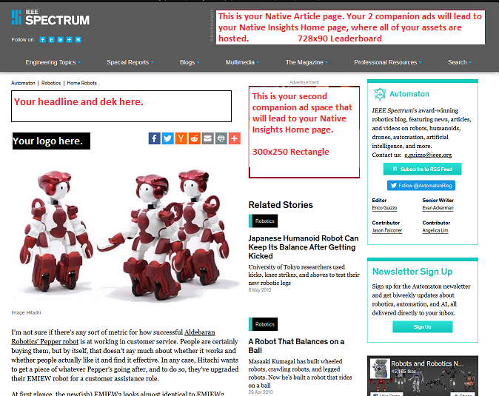

4) Appear under related stories
The Sponsor’s content asset box will also be included under “Related Stories.” The sponsor will allocate the tagged information to fit with the main spectrum.ieee.org navigation.
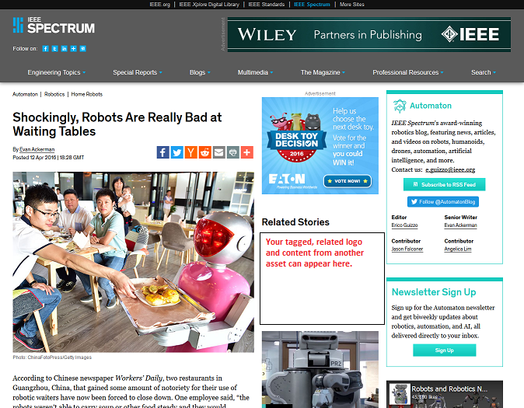

5) The Sponsor’s landing page
The Sponsor’s accumulated monthly assets will be consolidated and housed on their landing page. The provided content can be articles or white paper content or a blog post in the form of an article, video and/or open access webcasts. Videos will also appear on the IEEE Spectrum video landing page. One top leaderboard is provided for a banner to link to the Sponsor’s home page or product.
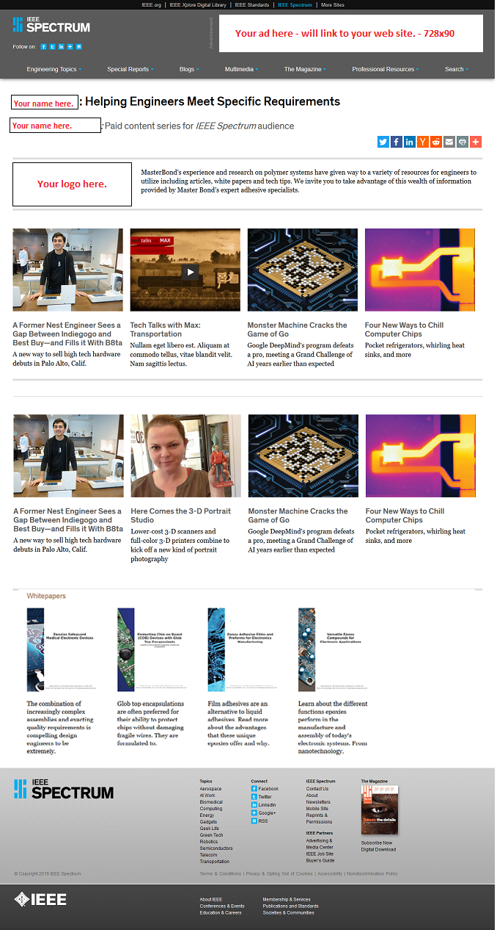

Best practices for the posts which will appear ROS in the above size boxes labeled “Sponsored”:
- The images should be associated with the content of the posts.
- Headlines should be able to stand completely on their own, and make a reader want to click on the post. The supplied article page URL will consist of the page headline. Many readers, whether through RSS or twitter, only see the headline.
- Dek (subhead): This is a one-line description of the content on this page.
- The banner ads for this page should contain a message that links to the Sponsor’s post page and/or landing page or other Native Insights content.
- Native Insights placements and ads are endemic by nature, and will match the form and function of the publisher’s digital platform.
- Use of images, videos, infographics etc. increase amplification to social media, as average engagement on referral traffic is 62% higher.
- Don’t sell — the content needs to be educational, information, helpful or interesting.

Production Schedule
The sponsor will provide the 8 posts with all the required content and graphics 12 business days
before the requested launch of the Native Insights campaign. Each subsequent month of the
campaign, 4-8 additional posts can be provided by the sponsor. The subsequent posts will be
published 4 days after the content is received, with one post published every alternate business day.
Deliverables
- 2 Brand logo images: 300 pixels wide and 140 pixels wide.
- 2 master images for each post - 620 pixels X 465 pixels and 300 pixels x 225 pixels. The images should be associated with the content of the post.
- For articles, white papers and blogs (which will both be posted in the form of an artcle): Headline: maximum of 50 characters including spaces; Dek (subhead): maximum of 120 characters including spaces; and Body Copy: minimum of 1200 characters including spaces.
- Banner ads: 728x90, 300x250 and 300x600 for the web and 468x60 and 300x50 for the newsletters (HTML5 gif), with link and 50 words alt. text. Max. file 50K, 15 sec., 3x Loop limit.
- Video Format: 5 min. max. with or without pre-roll. Videos should be delivered transcoded and optimized for web, in mp4, video codec H.264, AAC audio (both mono and stereo are acceptable), 1080p or 720p is acceptable.
- Pre-roll Master Image – 620x465, jpg/png/gif
- Logo – 120x120
- URL
- Title

